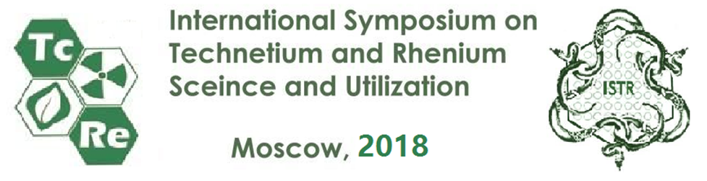
Date: 17 September 2018
№ 07-08-ISTR2018
Moscow, Russia

INFORMATION LETTER # 2

Dear colleges,
Russian Academy of Sciences, State Corporation on atomic energy (ROSATOM), Interdisciplinary scientific council on radiochemistry, MUCTR, IPCE RAS, FMBC FMBA will hold the 10th International Symposium on Technetium and Rhenium – Science and Utilization in Moscow, A.N. Frumkin Institute of Physical chemistry and Electrochemistry(IPCE) RAS on October 3-6, 2018.
Official Symposium website: www.technetium-99.ru
This Symposium is dedicated to the 100th Anniversary of Prof. Anna Kuzina, the famous Russian chemist in the field of technetium chemistry.
Professors from the largest universities and heads of nuclear centers from Russia, Australia, South Africa, Poland, South Korea, Japan, India, Germany, USA, China, France and CIS countries confirmed their participation in the Symposium.
A rich scientific program and informal communication of participants is the key to your professional success.
You can sign up for the 10th International Symposium on Technetium and Rhenium at the link:
https://online.mittech.ru/icc2017/en/register/
Payment deadline – September 24, 2018.
Sections:
1. Fundamental Physics and Chemistry of Tc and Re
2. Analytical Chemistry of Tc and Re
3. Tc in Nuclear Fuel Cycle and in the Biosphere
4. Re Hydrometallurgy
5. Tc and Re in Nuclear Medicine
6. Applications of Tc and Re, including their alloys in Modern Constructing Materials
7. Round Table: Tc and Re as a business projects
Detailed program you can find at the official Symposium website.
The Symposium language is English.
Venue: Leninsky prospect, 31-4, A.N. Frumkin Institute of Physical chemistry and Electrochemistry (IPCE) RAS, Moscow, Russia. http://phyche.ac.ru/index.php/contact
Looking forward to see you in Moscow!
Best regards,

Chairman of the Organizing Committee  Director of Technetium Laboratory  IPCE RAS, Prof. S.-E.C. | 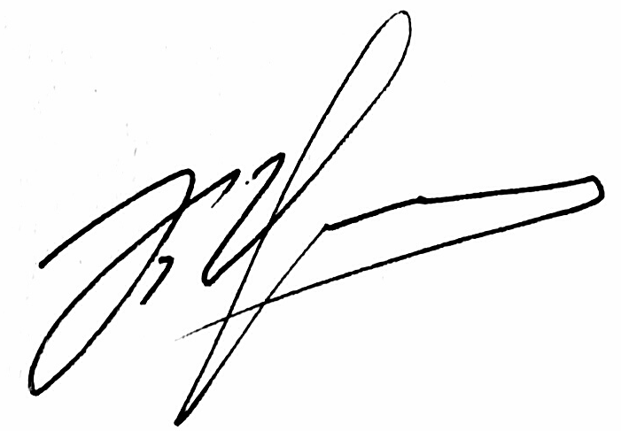 | K.E. German

Organizing committee: +7(495)335-2004, +7(903) 151-7554, guerman_k@mail.ru
Technical secretariat: +7(495)726-5135, +7(985)045-7465, info@mkcongress.ru

